**Integrity Constraints**

* Emp_info has two constraints named ‘primary key’ & ‘unique key’ & also has three not null constraints.
* Emp_office has a foreign key constraint .
* Department has only one primary key constraint .
* Branch has a primary key constraint **.**

**Business Requirements**

Concerning the Emp_info:

1. Emp_info has a primary key EMP_ID and a specific date of birth.

2. Emp_info indicates multivalued phone number .

3. Emp_info has a unique email address.

Concerning the Emp_office:

1.Emp_office has a foreign key emp_id & also hire_date.

2.Emp_office has two not null attributes named ‘deptno’ & ‘branch_no’

Concerning the Department :

1. Department has a primary key deptno.

Concerning the Branch:

1. Branch has a primary key branh_no.

Business Rule

The purpose of this system is to monitor the employee’s information as well as their working information.

* Enhance business performance

* Grow customer relationships
* Increase Profitability

**ER Diagram**

The scenario for the entity relationship diagram of bank management system is given below :

* Each emp_info has a emp_id, emp_name and a phone number.
* Each emp_info has a birthdate.
* Each emp_info has address and an email id.
* Each emp_office has a unique emp_id, salary, commission and a manager id.
* Each emp_office has a department number and a branch number.
* Each department has a department number and a department name.
* Each emp_info has a emp_office.
* Each emp_office can have several emp_info.
* Each emp_office works in a department.
* Each department has several emp_office.
* Each branch has a branch number, branch name, branch address and a branch officer.
* Each emp_office works in only one branch but each branch can have several emp_office.

ER-DIAGRAM

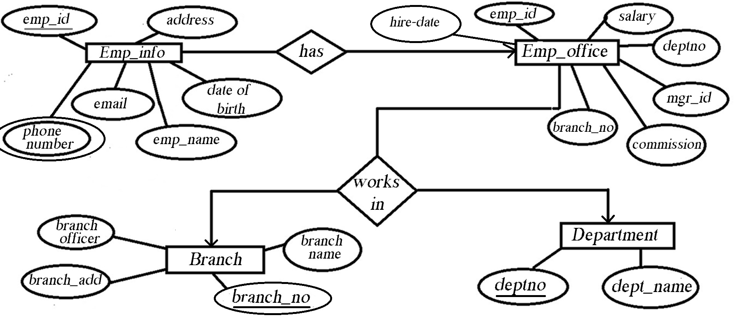

**Report**

The bank management system is to distribute or maintaining bank information. This bank has more than one branch and has same number of department. In every department, employee’s are working daily by maintaining the system. This system is to distribute work according to their department and there are managers to to check that.

To maintain all these, 4 tables were created. In this table,emp_office is the main table because this is the only department where every table is connected. By using emp_id from this table, we can collect employees information. We also used deptno and branch_no attribute to collect information about department from department table and branch information from branch table.

**Normalization**

1NF:

1st table:   Emp_id ,Emp_name, Phn_no,Address,D_O_B,Email,Sal,Comm,Hiredate,Mgr_id,Branch_no

2nd table: Branch_no,Branch_name,Branch_add,Branch_officer

3rd table: Deptno,Dept_name,Emp_id

2NF:

1st table: Emp_id ,Emp_name, Phn_no,Address,D_O_B,Email,Sal,Comm,Hiredate,Mgr_id

2nd table: Branch_no,Branch_name,Branch_add,Branch_officer

3rd table: Deptno,Dept_name,Emp_id

4th table: Branch_no , Emp_id

3NF:  
1st table: Emp_id ,Emp_name, Ph n_no,Address,D_O_B,Email  
2nd table: Emp_id ,Sal,Comm,Hiredate,Mgr_id  
3rd table: Deptno,Dept_name,Emp_id  
4th table: Branch_no,Branch_name,Branch_add,Branch_officer  
5th table : Branch_no , Emp_id

1. Problem: Finding all the office information about ‘Zia’.

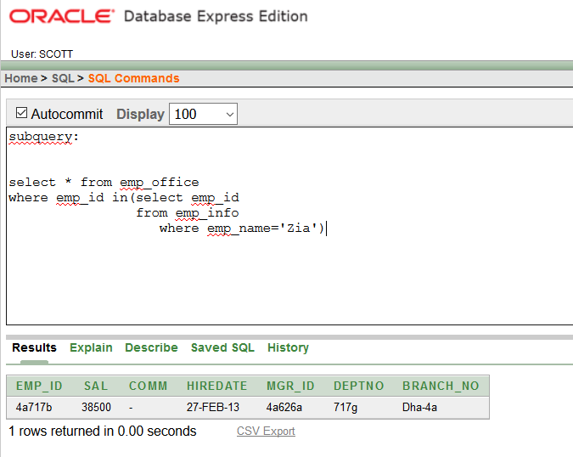

1. Problem : Finding the employee id and name of employee who get lowest salary,

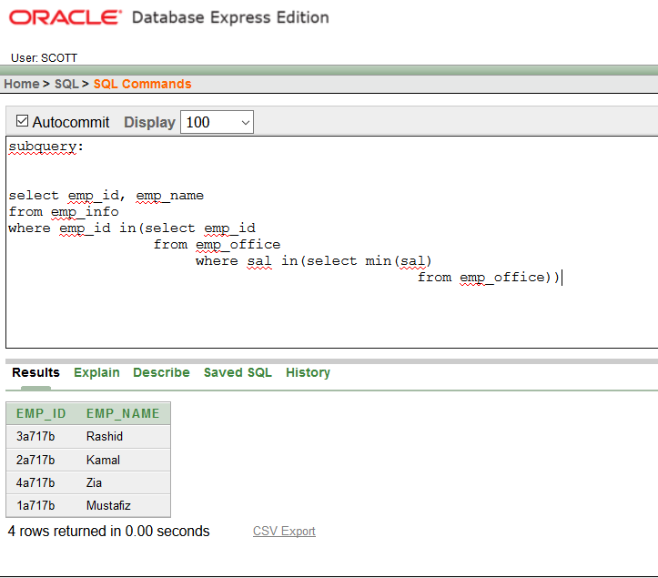

1. Problem: Finding the employee id and name of the employee who join after 2013

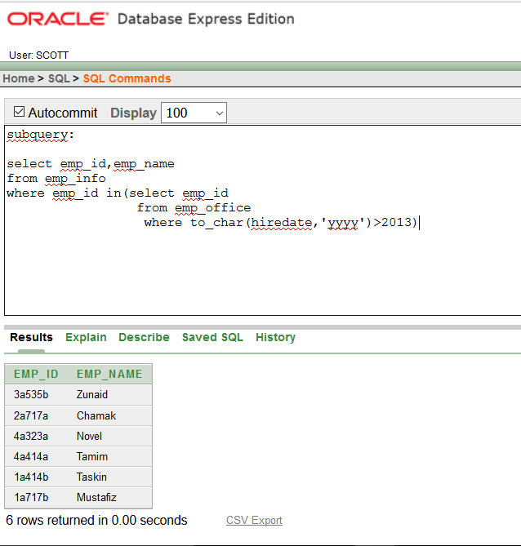

1. Problem: Finding the highest paid employee of a branch

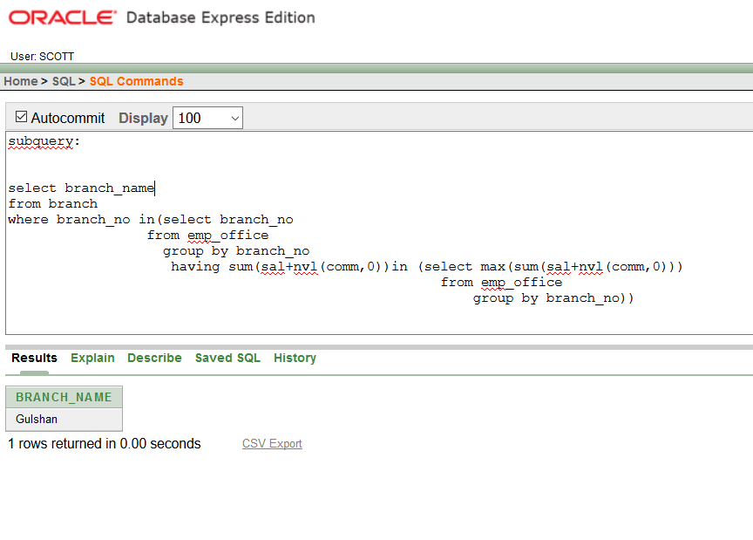

1. Problem: Showing the id , name ,salary, commission and total salary of those employee

Who get commission.

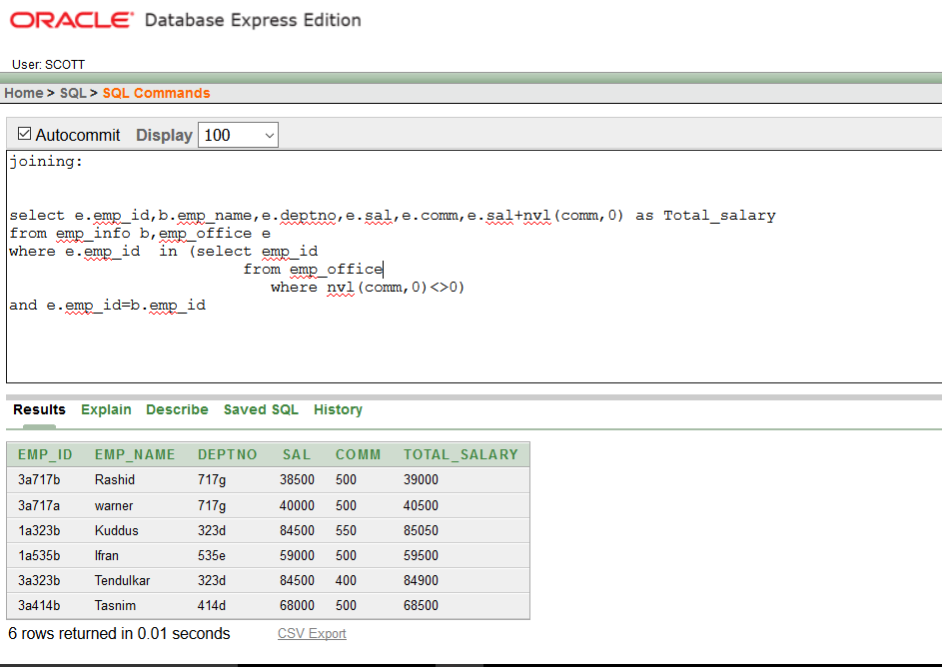

1. Problem: Finding the deptno , id, branch name, branch address of those employee’s

Whose 1st three deptno character is 323.

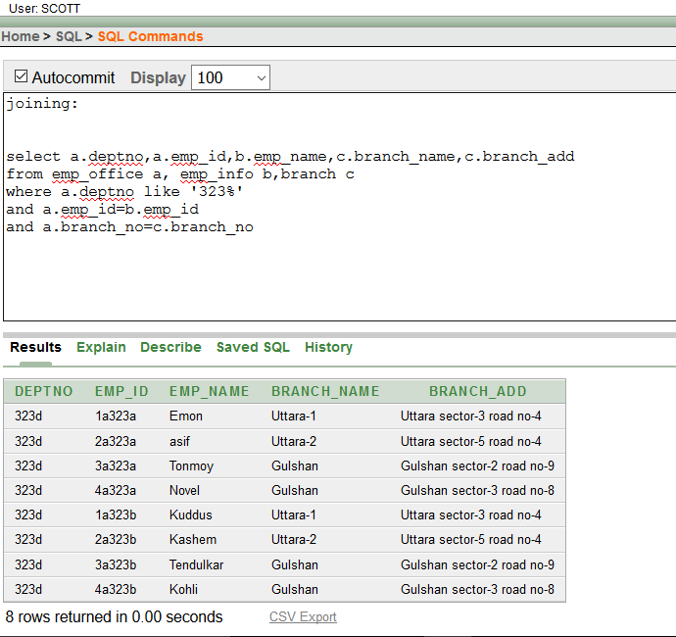

1. Problem: Finding the department no, employee id and name of those employee’s

Who work in ‘Uttara-1’ branch.

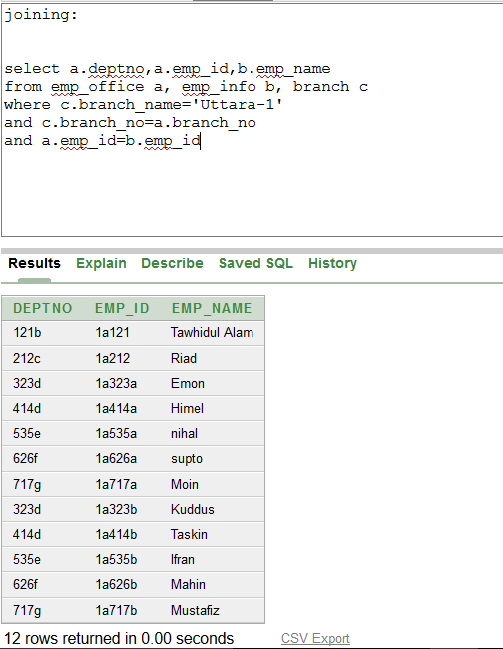

1. Problem: Showing those employee’s information who work under branch officer name

Tawhidul alam.

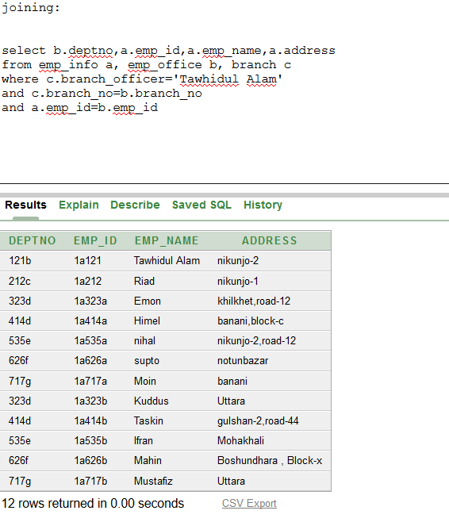

**#View Creation Screen Shoot with Data(complex):**

1. Problem: Creating a branch wise view including information about branch name, minimum salary, maximum salary, average salary, total salary

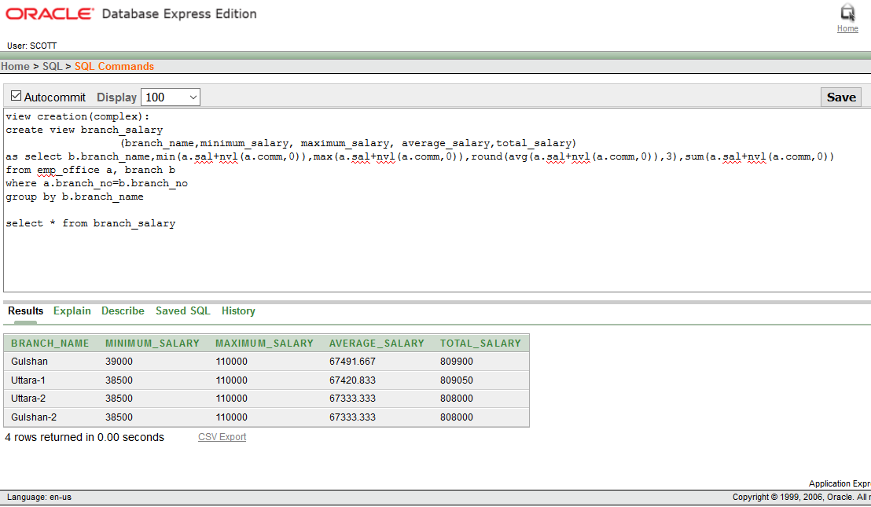

1. Problem: Creating a department wise view including information about branch name, minimum salary, maximum salary, average salary, total salary

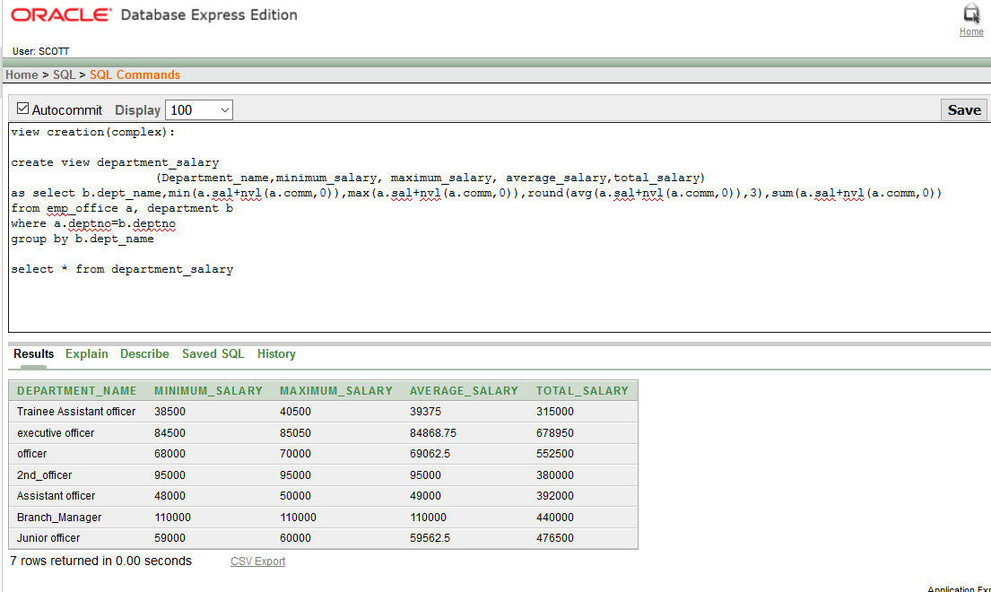

**#view creation(simple):**

1. Problem:

Creating a read only view including employee id, name, hire-date information of those employee’s who work in 717g department.

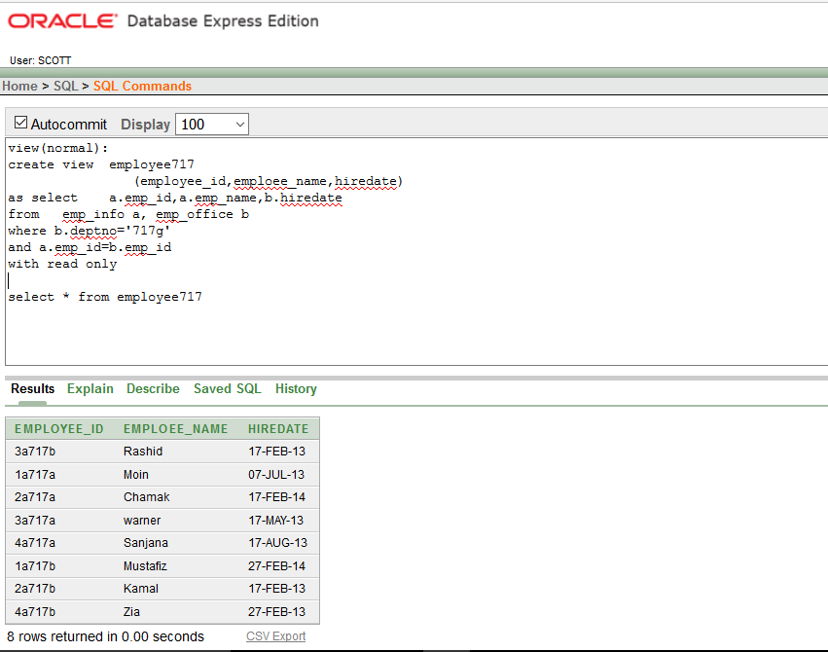

1. Problem: Finding employee id ,name, salary of those employee whose employee id 3rd,4th,5th letter is 414.

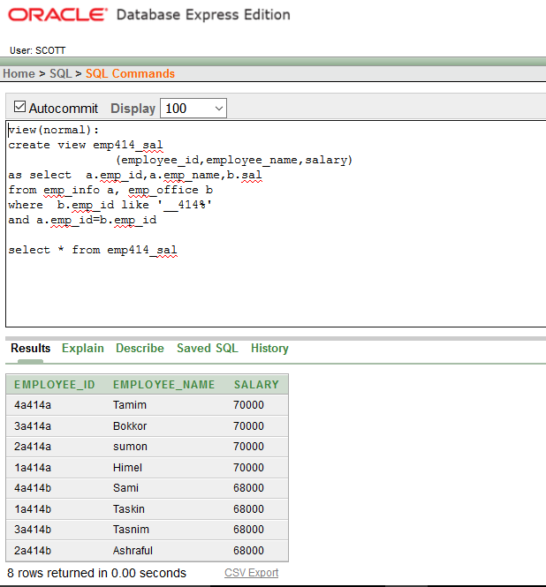

**#Unique constraint for email(Disable):**

# 

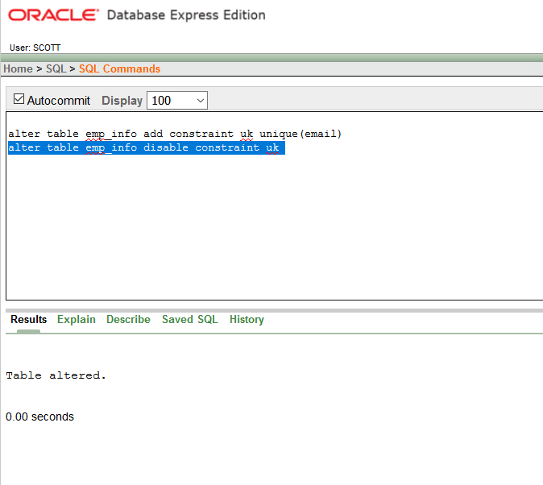

**#Enable constraint :**

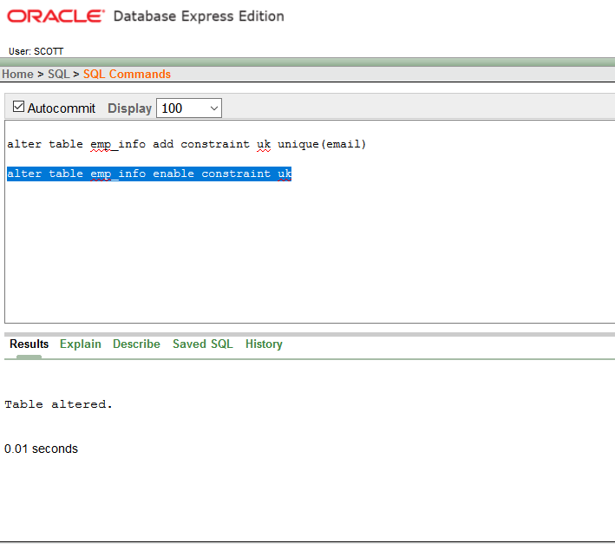

**#Table Names:**

**1. (Emp_info , 48 rows)**

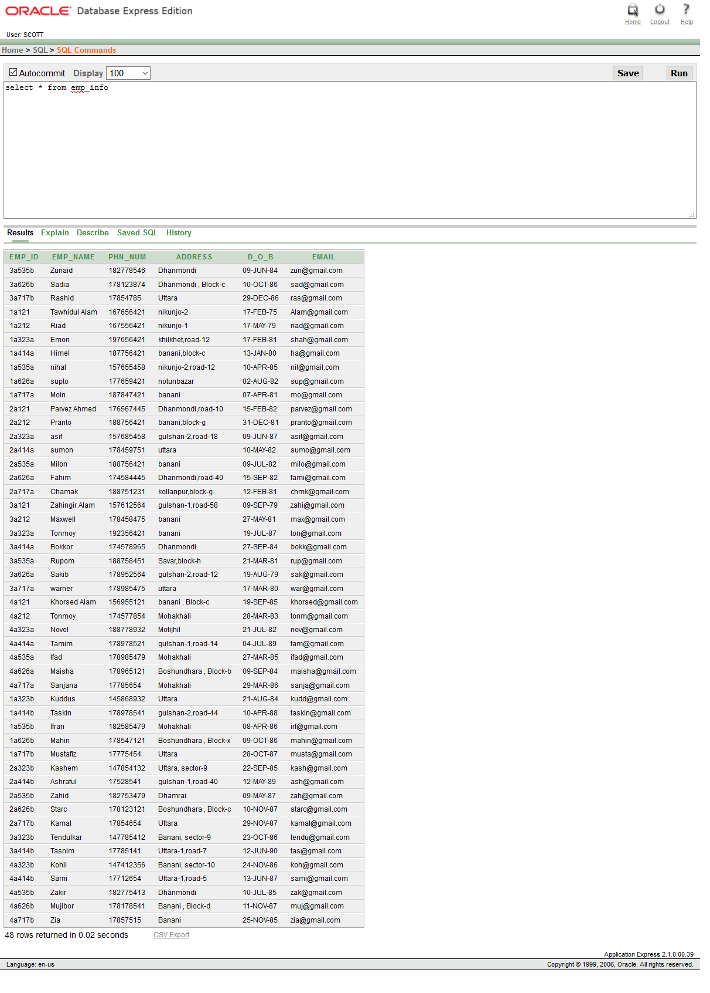

**2.Table(emp_office , 48 rows)**

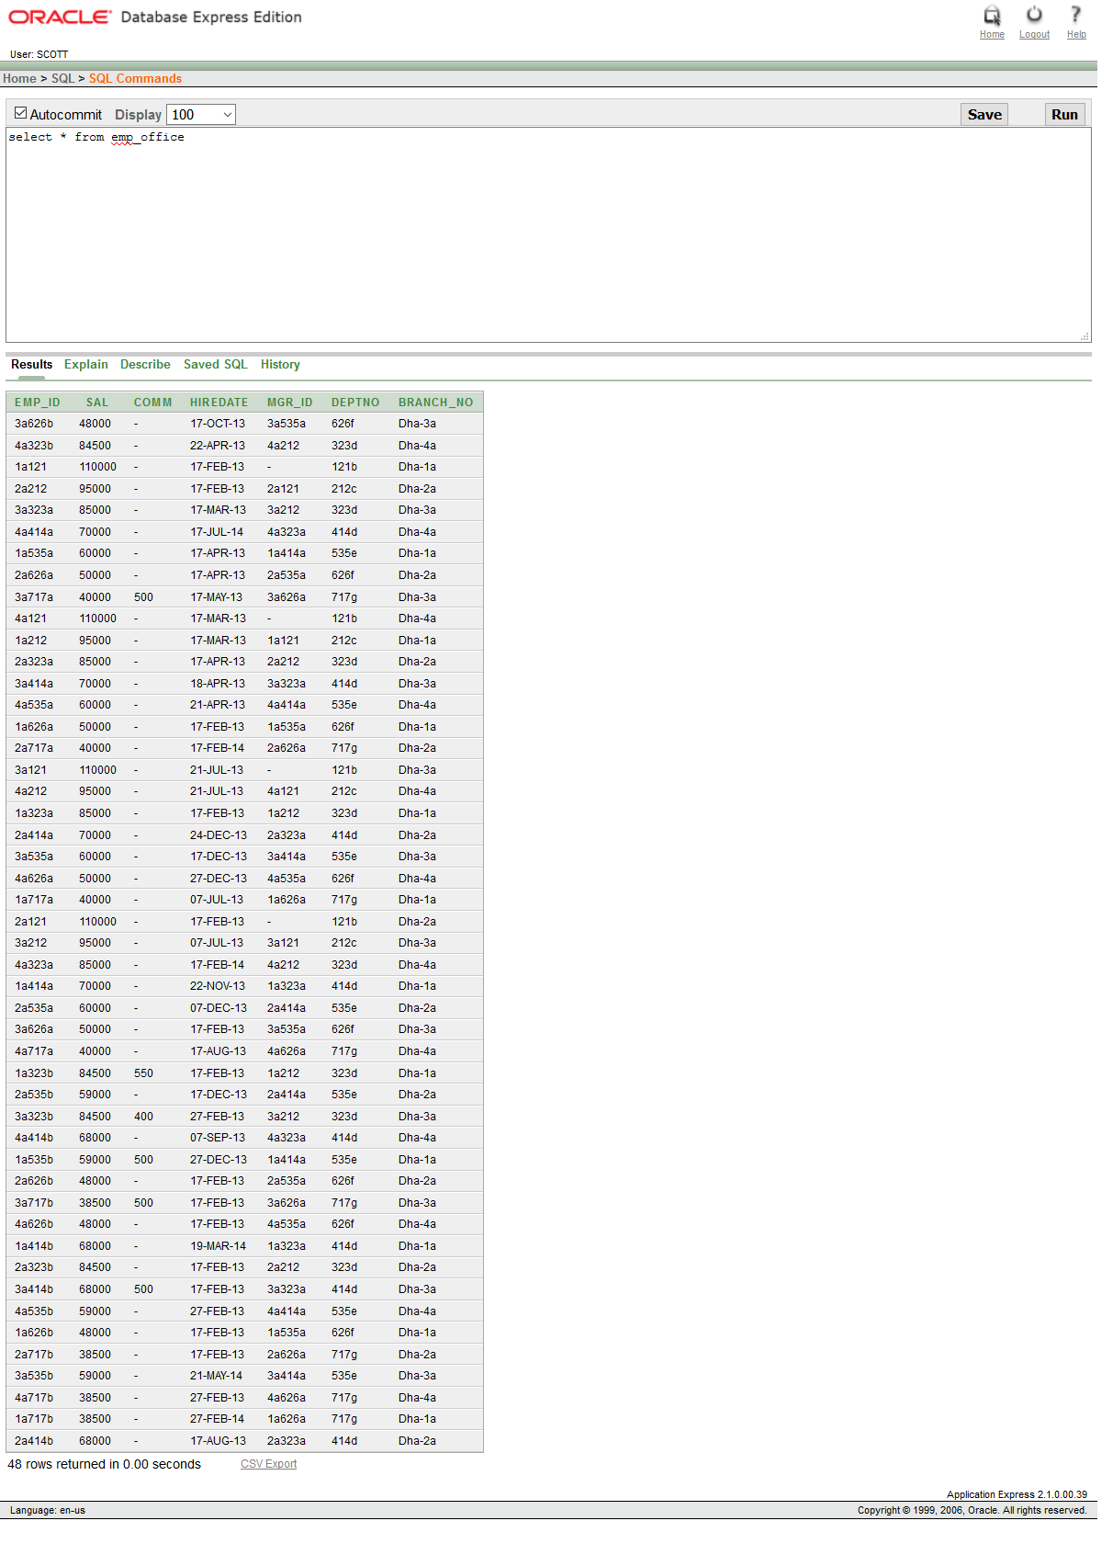

**3.Table(Department , 7 rows)**

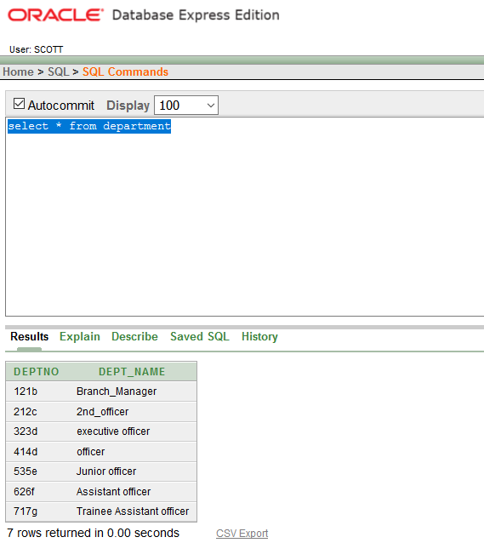

1. **Table (Branch, 4 rows)**

